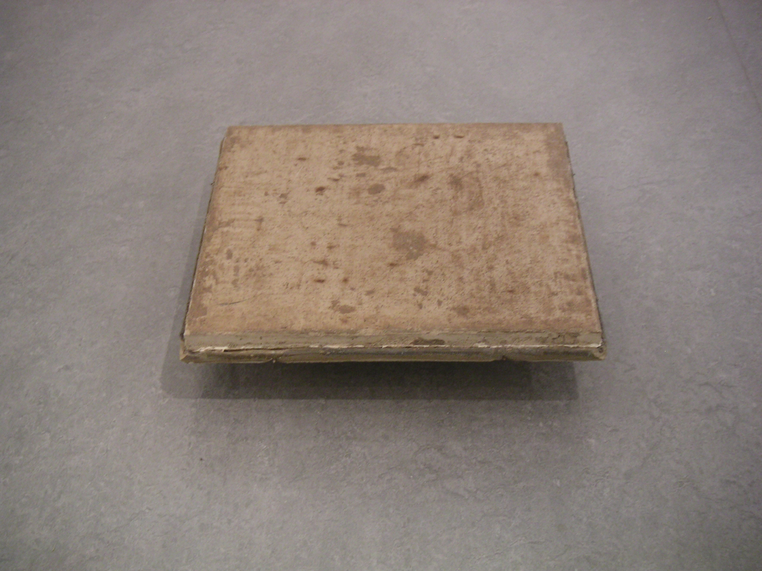

‘Presence’

Action Research

Course Evaluation Report

MA by Project

2006 - 2008 Full Time

Andrew Henon

University of West of England School of Creative Arts

Contents

Chapter Headings Page Number

Introduction …………… 2
Background Context …………… 3

The works work begins …………… 4

A living theory of arts practice …………… 5

Dependency Denial Defence …………… 7

Culmination …………… 15

Summary Conclusion …………… 20

Bibliography …………… 22

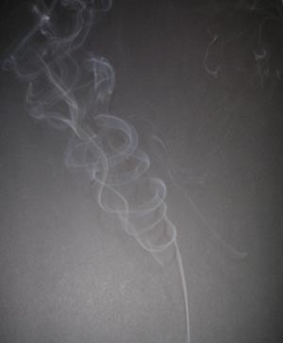
Path of vortices created by smoke as it slows down and meets water molecules in the air.

Introduction

I began the MA with the question

“How do I improve my creative practice as an artist?”

Such an enquiry opens up, exposes the fragility, vulnerabilities and weaknesses. It brings forward the strengths, the substantial, resilient and sustainable. Within the structure of the MA I researched and designed a proposal for the exploration of the nature of creativity and change.

“Competition in the sense of wanting to do better than you did before is not bad” Dalai Lama.

The intent was to provide an extreme environment and turning point of change within which a new set of physical, emotional and mental experiences would be encountered. To then create work to gain an insight into the nature of creativity. This environment would be created by dealing with an issue of addiction ‘Giving up Smoking’ as a catalyst for change. This, as a lifelong smoker, provided a personal challenge comparable to Michael Landy who in ‘Breakdown’ systematically disposed of his material belongings. I have been a heavy smoker from a young age and was born into a smoking household. I associate smoking with home, studio practice and reflective working processes. For me to consciously decide to ‘Give up smoking’ is to create an extreme environment.

Previous art practice had indirectly and as a result of their practical production forced me to deal with overcoming fear for example; ‘Hidden Depths’ the fear of swimming, finally swimming after 30 years in 1994, ‘Casting the Light’ fear of heights. The subject of fear had not initially been the subject these issues occurring later during project delivery.

This current project would push my creative abilities to their limit and that the art works produced, the process and manner of making would reveal insights into the nature of creativity.

The contents of this evaluation aim to show how my thinking and practice has changed during this research, how it has improved and developed. I will briefly discuss the background context of my work. I will show the development of this work and place it in the context of ‘Action Research’ and ‘Reflective practice’.

This enquiry has led me to challenge 30 years of professional artistic practice. The underlying core values and principles of that practice pre and during MA will be discussed.
I will explain and evidence the change in thinking that has occurred and place this in context with the work of others and in what ways my work may be similar or different from.

The environmental movement has now become main-stream. It is as a matter of urgency that I confront head on my own core values and principles. This begins with my own wellbeing, health, state of mind and psychology. It is imperative that I do this if I am to continue my work within the field of participatory socially engaged practice and community arts.

In order to do this I will show how I have improved my practice and in what ways.

Background Context

The philosophical base on which my work and life is founded is called ‘Ecosophy’ which is described in the Penguin Dictionary of Philosophy as derived:

“From the Greek words for ‘household’ and ‘wisdom’ ecosophy is the wisdom of living in harmony with what is one’s household in the broadest sense, that is, nature.”

The Norwegian philosopher Arne Naes founded and named ‘Deep Ecology’ in 1973 based on the environmental movement with ‘Ecosophy’ at its core. I became involved in the Environmental movement of Friends of the Earth and Greenpeace in 1978.

As a result of these influences I do not separate out my lived experience into separate functions, definitions and classifications. For example: home, work, social life etc they interact, inform across boundaries, and barriers, and blur into one lived experience.

“The new paradigm may be called a holistic world view, seeing the world as an integrated whole rather than a disassociated collection of parts” Fritjof Capra;

“Everything co-exists with this sheet of paper. That is why I think the word inter-be should be in the dictionary. “To be” is to inter-be. You cannot just be yourself alone. You have to inter-be with every other thing. This sheet of paper is, because everything else is” Tich Nhat Hanh

This philosophy is complemented by the work of Joseph Beuys that “Every Human Being is an Artist” and “To be a teacher is my greatest work of art” together with theories of ‘Social sculpture’ ‘a Social organism as a work of art’

‘I know I can not teach anyone anything; I can only provide an environment in which he can learn’ Carl Rogers1965. This statement is an underlying principle of a student centred approach to learning that I employ in participatory socially engaged arts practice ‘Community Arts’. It opens up possibilities for engagement as artist/tutor/learner/educator.

In the past I have worked on the conceptual idea of removing the ego from my work, both in its production process and end product. This work manifests, working with nature to expose what already exists or to work co-creatively with others. In these ways I have remained anonymous, the work apparently authorless to those that encounter it.

‘What difference does it make who is speaking’ Michael Foucault

All the above I have embodied as underlying core values and principles on which my initial philosophical position and living theory of practice is based. I have questioned the validity and integrity of this approach throughout this action research enquiry in the context of:

“How do I improve my creative practice as an artist?”
.
“Don’t be afraid to take the past head on” Tracy Emin

The Works Work Begins

“The works work”
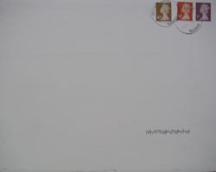

The piece shown above was ‘self addressed’ and posted on the first day of the MA. To let go the work, to release it, myself from preciousness, let others, mechanics of the postal system, make their mark, trust the return, to accept the serendipity. It was made through the repetitive layering of painted gesso. This work embodied how my painting practice had become, blocked, obsessive, repetitive, stagnant and directionless.

This project tackles the fear of ‘Giving up Smoking’ ultimately fear of failure.

To do this I kept a daily document of the consumption of cigarettes. Daily collections of all the cigarettes I smoked provided a documentary record and a collection of materials. These were then used in different ways over 18 months. The materials were then used in the production of art works. Thoughts were captured through the making process itself as a form of meaning in the making.

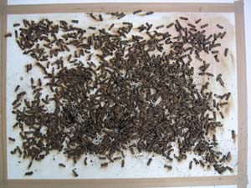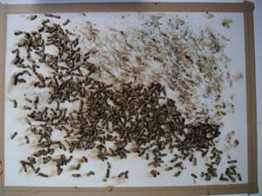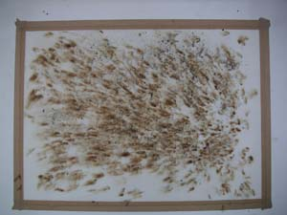

Examples of making process in the production of drawings and prints

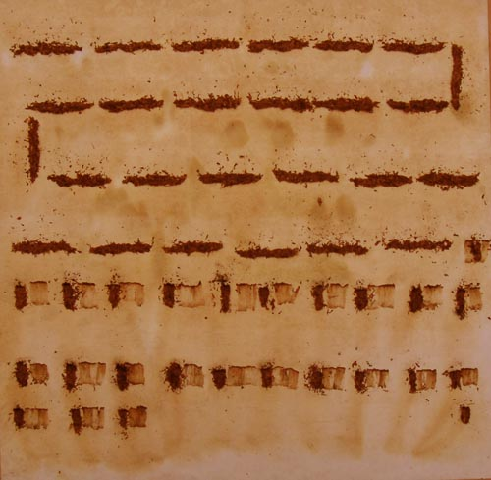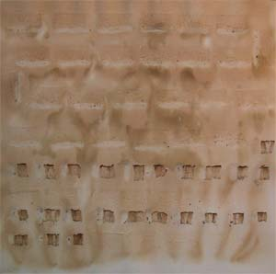

A living theory of arts practice

An action research enquiry

The structure of the MA has enabled a framework and set of parameters within which I have been able to;

‘Create a Living educational theory’ Jack Whitehead

The methodology behind this explores the implications of asking, researching and answering, ‘How do I improve what I am doing? Whitehead, Action Planning

Specifically

“How do I improve my creative practice as an artist?”

Whitehead explains in detail in his paper on living educational theories how it is possible to create your own living educational theory. In his paper ‘Action Panning in creating your living educational theory he states:

“Your living educational theory is your explanation for your educational influences in your own learning, in the learning of others and in the learning of the social formations in which you are living and working”
Whitehead in his recent paper for the educational research association quotes Jean – Francois Lyotard

‘A postmodern artist or writer is in the position of a philosopher: the text he writes, the work he produces are not in principle governed by pre-established rules, and they cannot be judged according to a determining judgement, by applying familiar categories to the text or to the work. Those rules and categories are what the work of art itself is looking for. The artist and the writer, then, are working without rules in order to formulate the rules of what will have been done’

The question is deconstructed

“How do I improve my creative practice as an artist?”

This question provides the underlying question behind my study at MA level. It also provides four further questions.

- What is the nature of creativity?

In order to improve it a deeper understanding is required to effect a change.

- What is the nature of my practice?

Does it maximise and apply creativity to its full potential?

- How do I define or describe the term artist?

What does being defined as an artist mean to me? And to others?

The first question ‘What is the nature of creativity’? This is where I began, adding to this question the issue of change becoming ‘What is the nature of creativity and change?’ Change relevant to the question

- ‘How do I improve my creative practice as an artist?’

How do I change it for the better?
Dependency Denial and Defence

“Since the fall of the Berlin Wall, a phrase has been used to describe the outlook of former residents of the communist GDR who can’t quite get over the fact that their country has been subsumed into its larger, richer, democratic neighbour. They call it der Mauer im Kopf, or ‘the wall in the head’.

- What is the nature of creativity and change?

In order to improve it a deeper understanding is required to effect a change

In order to improve it a deeper understanding is required to effect a change in relation to the question “How do I improve my creative practice as an artist?”

The fundamental basis of the question was flawed in its generality. I believed it possible to extrapolate out from an answer to this question insight that would be applicable to everyone. I now realise this to have been misguided. This was my personal wall in the head I had made a number of assumptions based on personal experiences of the past and anecdotal evidence. These assumptions associated creativity with exclusion and self exclusion as being a prerequisite for creativity and its growth. This is a myth and worst I have been perpetuating a personal ideological mythology.

“Myths are nothing but this ceaseless, untiring solicitation, this insidious and inflexible demand that all men recognise themselves in this image, eternal yet bearing a date, which was built of them one day as if for all time. For the nature, in which they are locked up under the pretext of being eternalised, is nothing but a Usage. And it is this Usage, however lofty, that they must take in hand and transform” .

And

“Creativity is rarely, if at all, a matter of the individual creator creating in splendid or miserable isolation”

I can however ask the question

“What is the nature of my own creativity?”

Whilst my own creative process is linked to exclusion and self exclusion; I believed that it provided an outside view an outsider’s perspective. Childhood experiences of dyslexia and bullying leading to periods of self exclusion were continued and re-enforced in adulthood with my misconceptions. I now understand that in focusing on the negative experiences and believing they were at the heart of creativity, it was in fact the positive support that I received through these experiences that had a greater impact on and enabled my creativity.

“To be truly creative you need strong social networks and trusting relationships”

Smoking has its own mythology in life and family history. I associated it with four different conditions that each relate to one another. I associate smoking with; home, I grew up in a smoking Household, a social bonding mechanism, creativity and the reflective process of making. I have an addictive personality, related to obsessional behaviour linked to earlier childhood instances of attention deficit hyper activity disorder (ADHD)
I believed that smoking enhanced reflective practice, therefore helped and aided the creative expression. The assumption that ‘Smoking’ increases creativity through reflective working practice, I find now to be false and another myth.
If one watches video footage of Rothco, Pollack, Picasso and Hockney one can observe the interaction between reflective thought, making and smoking.
Hockney says “I love cigarettes, I love the taste,” Hockney goes on to talk about the loss of bohemia through the public smoking ban”
However
Susan Greenfield identifies the problem in her analysis of the human brain.
“Perhaps acetylcholine simply makes the hippocampus and thalamus more alert, and hence better able to process memory. One only has to think of the effects of smoking to see the attraction of this idea. Ex smokers are only too aware of the beneficial effects that nicotine, which acts as an impostor for acetylcholine, can have on concentration and mental powers generally”
So if we assume that smoking enhances concentration and memory, and therefore reflective creativity, what of the many artists that do not smoke? Where does their work stand on the creativity quotient? It is not nicotine or smoking that aid creative concentration or reflective thinking. Nicotine is the actor playing the role and part of acetylcholine. Some artists may have higher levels of natural acetylcholine thereby removing nicotine from the equation. That is not to say that acetylcholine levels are a prerequisite of creativity either simply that by its presence it negates the importance of nicotine it self.
I thought I would become less creative if I stopped smoking. I presumed smoking to be an aid to reflection. I no longer believe this.
I did not manage to give up smoking and thereby create the new extreme condition, the experiential place from within which to produce new work.
A different extreme condition was however to develop.
Unlike in March 2005, When 20 artists embarked on an expedition to the Arctic, they included novelist Ian McEwan, Antony Gormley, Rachael Whiteread and Siobhan Davies. They experienced working and living in extreme temperatures of minus 30 degrees C.
Here the extreme is the physical environment the intent is to produce work as a direct response to it and with it. The extreme conditions provide the parameters the context placing limits, boundaries and relationships to work with or against. The decision making process is constrained to within these clearly defined parameters to the extent of life and death the margins for error are very slight. Still the intention is to push these boundaries as far as possible.
The extreme conditions produced by ‘Giving up smoking’ or ‘Dealing with addiction’ have permeable boundaries and movable barriers it is a process, a fluid dynamic relationship. The margins for error are extremely large the determining decision making process unrestrained. The constraints are linked to intrinsic motivations not extrinsic conditions, whilst there are extrinsic pressures they are not insurmountable if one is determined to continue smoking.
In answer to the questions, ‘what is the nature of creativity and change’?

And in order to improve it, a deeper understanding is required to effect a change
I can only refer to my own creativity. I improve my practice through pushing the boundaries, and barriers with periods of intensive activity, condensed and intense focus combined with and interspersed with periods of reflection, questioning and sustained commitment.
My practice is improved by a continual, sustained process of action research and reflective practice. The new extreme conditions created were conditions of extreme withdrawal and extreme consumption a fluid dynamic process of ‘boom and bust’ ‘crash and burn’.
Feelings of failure fear of failure, and guilt, put additional pressures on the existing, psychological, physiological strains and stress levels. Imagination holds valuable keys and a role to play in the visualisation and more positive outlook in the overcoming of such pressures.
My creativity or capacity for creativity is like a muscle or the neural networking of the brain the more I exercise it, nurture it, feed it with questions of enquiry of many different kinds, challenge it and accept it the more it develops and grows.
Work produced in extremes and extreme works

- What is the nature of my practice?

Does it maximise and apply creativity to its full potential?

Nicotine reduction

“I work very hard and I never - never! – get people to understand what I mean”
Louise Bourgeois

The timed emotional abstract expressionist pieces

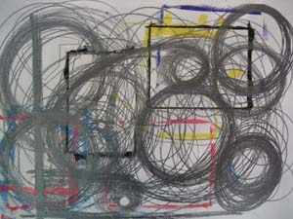
Title 3hrs

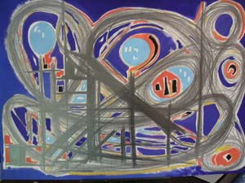
Title 5hrs 10 minutes

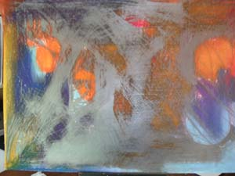
Title 5 hrs 40 minutes

The above paintings were created during a process of intensity during attempts to give up smoking. The intent was to express emotions and the conditions experienced directly in the production of new work. The manner of this production was based on a predetermined set of rules and strictly defined parameters. Each work begins with a plain sheet of paper. The rules for which I determined as:

- Allowed to use any materials to make marks on the paper

- Allowed to begin painting or drawing when I want a cigarette and so long as I do not give in to this desire, craving, need I can continue to paint.

- As soon as I give in to the craving and have a cigarette I can not return to the work, the work remains finished at this stage, there are no aesthetic considerations allowed other than those made in the time achieved.

- During this time the marks I make the decisions I decide are not connected to a smoking based reflectivity.

- The process of smoking is held either side of the production time, this time becomes the title.

These works are a record of this process however they do not communicate the intent to communicate and convey the expressed emotions and the conditions experienced. The anxiety, the pain, the expression and anger, all the emotions intrinsic in the making do not succeed to communicate extrinsically to the viewer. They are neither implicit or explicit.

“Knowledge exists if, first the statement is intelligible, and second; if “cases” can be derived from the experience which “corresponds” to it”

In my attempt to impart knowledge to the viewer I failed on both counts the paintings do not show adequately the level of the emotions or rather they can be misinterpreted and in either case are unintelligible to read on the intended levels. The pieces do not even relate to any corresponding experience or relate to other “cases” sit in a particular canon or refer to a cohesive body of work.

Louise Bourgeois in an interview with Donald Kuspit states

“What modern art means is that you have to keep finding new ways to express yourself, to express the problems, that there are no settled ways, no fixed approach. This is a painful situation, and modern art is about this painful situation of having no absolutely definite way of expressing yourself. This is why modern art will continue, because this condition remains: it is a modern human condition……it is about the hurt of not being able to express yourself properly, to express your intimate relations, your unconscious, to trust the world enough to express yourself directly in it. It is about trying to be sane in this situation, of being tentatively and temporarily sane by expressing yourself. All art comes from terrific failures and terrific needs that we have. It is about the difficulty of being a self because one is neglected. Everywhere in the modern world there is neglect, the need to be recognised, which is not satisfied. Art is a way of recognising oneself, which is why it will always be modern”.

These pieces are however symbolic, full of emotional content for me and for this reason alone important pieces to me, unresolved, half finished, suspended, fragmented, mixed aesthetics, colour, composition there is much for these pieces still to say to me in the future and as they will not be reworked by me they remain close to my heart.

As Per Pegelow identified during a critical analysis;

“Your project is not about giving up smoking it is about smoking”

The environment that I succeeded to create was a moving, shifting, fluid process. This process moved between extremes from managing to extend times of not smoking to times of extreme exposure to nicotine. Reduction of consumption was a matter of a few days and reducing nicotine intake to three or four cigarettes over two or three days on several occasions over 18 months.

This was however balanced with extreme exposure to nicotine both through chain smoking at times of high anxiety and stress and the use of the nicotine materials themselves in the production of new work. This process has continued to culminate and is manifest in the final body of work.

In attempting to create the extreme that was intended ‘Giving up smoking’ it produced the opposite effect, an extreme of another kind, an extreme consumption and exposure to nicotine, pushing the boundaries of both my own health and safety and the health and safety of others.
“You learn the most from what you want the least, because then you have to transgress your fears and limitations” Marina Abramovic
Nicotine increase

During the project I recorded the process of giving up smoking in a number of ways.

- Representation, documentary and recording through the use of photography
- A number of installations using the materials, consumable objects and relationships between consumerism, addiction and cultural shifts
- Documentary evidence of the current cultural and social changes
- The documentation through the collection of physical materials, including the remains of hand rolled cigarettes, the contents of daily ashtray emptying, packaging and other associated materials.

After a critical reflection on the reception of the ‘timed emotional content pieces’ I took the decision to actually use the materials I had collected.

Both Sarah Lucus and Tracy Emin have used smoking as a subject in their work.

Having looked at the work of Sarah Lucus With ‘Fag Show’ 2000.

The Tate review in an article provided by grove arts states:

“In her solo exhibition The Fag Show (London Sadie Coles 2000) she explored her obsession with cigarettes as a material for art, suggesting the connection between smoking and sexually obsessive activity. Self portrait with cigarettes (2000; London, Satchi Gal.), a self-portrait made with cigarettes, makes a connection between the obsessional, introverted activities of smoking and drawing”
In an earlier work ‘Where does it all end’ 1994 Wax and cigarette but. The association with mortality is within the title and marks the start of Lucus’s work with the issues of smoking.

I realise that my work is not just about smoking or addiction although these are important issues. My work is centred on the enquiry of placing myself in an extreme position, a position of change.

My work relating to the increase in nicotine exposure comes directly from the use of the materials of nicotine in the work.

There may be a connection between sexually obsessive activity and smoking and possible connection with obsessional introverted activity. No doubt in my case there is with regard to obsessional introverted activity in the past relating to my painting. My interest is in pushing materials and myself. During this process and the outcomes I exposed myself to excessive nicotine intake through the skin this had a number of effects.

- It increased dependence on nicotine, thereby reinforcing the addiction.
- The resulting objects became hazardous for a period of time whilst the materials settled, dried and condensed.
- The toxic quality of the work became over powering to the point of danger.

The creative process I employ in the production of work is a process of co-creativity with nature.

Gerhard Richter explains this very well:

“28 March 1986. […] Art is based on these material preconditions. It is a special mode of our daily intercourse with phenomena, in which we apprehend ourselves and everything around us. Art is therefore the pleasure taken in the production of phenomena that are analogous to those of reality, because they bear a greater or lesser degree of resemblance to them. It follows that art is a way of thinking things out differently, and of apprehending the intrinsic inaccessibility of phenomenal reality; that art is an instrument, a method of getting at that which is closed and inaccessible to us (the banal future, just as much as the intrinsically unknowable); that art has a formative, investigative and speculative function: it is thus not only existential pleasure but Utopia”

“21 April 1986 […...] It also conforms to a general principle of nature; for Nature, too, does not develop an organism in accordance with an idea: Nature lets it’s forms and modifications come, within the framework of it’s given facts and with the help of chance.

“12 October 1986. What shall I paint? How shall I paint? ‘What’ is the hardest thing, because it is the essence. ‘How’ is easy by comparison. To start of with ‘how’ is frivolous, but legitimate. Apply the ‘How’, and thus use the requirements of technique, the material and physical possibilities, in order to realize the intention. The intention: to invent nothing- no idea, no composition, no object, form, idea, picture”

In painting I paint firstly from this abstract position however this position is not as purist as Richter with respect to the paintings in my final body of work.

In answer to the questions, what is the nature of my practice?

And does it maximise and apply creativity to its full potential?

The nature of my creativity is a process of co-creativity the co-creativity of being and becoming. It is a process that works with nature and is broadened out to include working withy others. It combines the personal with the subjective, the objective and the public. My practice has been challenged, it has been subject to extrinsic critical analysis and I have intrinsically been driven, self driven and motivated to push the boundaries of my work as far as they can go. In this way I have expressed my full creative potential, stretched my practice as far as I can at this time. I do not know if this is the limit of my creative potential I can only continue to push the boundaries in the future.

- How do I define or describe the term artist?

What does being defined as an artist mean to me? Others?

And

- ‘How do I improve my creative practice as an artist?’

How do I change it for the better?

In the production and presentation of my final work I shall attempt to answer the above questions. The making of the work will describe the artist, it will present the work to others and in their eyes the term will be defined.

In the making of the final pieces I could be described as an artist, sculptor, maker, and painter. In the presentation of the work I could be described as an artist, communicator, designer, teacher and learner.

Through the making process as a reflective process my creative practice has been challenged and pushed. I have pushed the materials as far as I can and in the process pushed my own body further than is recommended for health and safety. I have put my own wellbeing at risk and I am aware of the possible irresponsibility of these acts. I am acutely aware now and have addressed the health and safety issues encountered in the presentation of the final work.

Culmination

‘Presence’

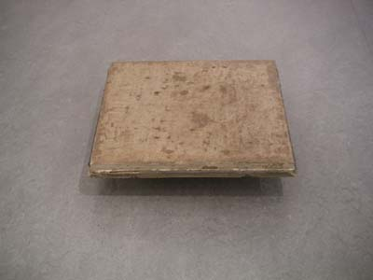

In the making of presence the materials used were those collected over a period of six months. Its making was in response to the earlier failure of the ‘timed emotional abstract expressionist pieces’ to embody and convey intent, meaning and the desired content.

Presence is materials based it is what it is, raw, heavy, full of material content and references. It refers to the modernist and constructivist approach to materials of content and form.

“[….] the content and form. These two elements are from constructive point of view one and the same thing. It does not separate Content from form – on the contrary, it does not see as possible their separated and independent existence” Naum Gabo

Whilst it has a constructivist genealogy it also has a post modern context

“Modern aesthetics is an aesthetic of the sublime, though a nostalgic one. It allows the un-presentable to be put forward only as the missing contents; but the form, because of its recognizable consistency, continues to offer to the reader or viewer matter for solace and pleasure”.

“Yet these sentiments do not constitute the real sublime sentiment, which is in an intrinsic combination of pleasure and pain: the pleasure that reason should exceed all presentation, the pain that imagination or sensibility should not be equal to the concept”.

Presence is a heavy piece in weight yet it is supported above ground level it appears to float in space. It is at once made important yet below us, accessible yet inaccessible.

‘Presence’ is a contradiction a metaphor for my own ‘living contradiction’

The making of ‘Presence’

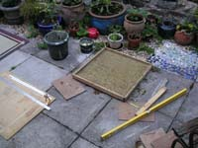

Six months of hand rolled cigarette ends and 3 ounces of tobacco were mixed with plaster and poured into a mould shown above. The mould was then emptied into a new frame mould and concrete added to stabilise the materials. This was then presented at the end of semester 2. Presence has now been removed from this supporting frame to stand alone as a piece of material in its own right.

A number of minor supporting works produced from similar materials were produced that explored various issues including ‘baking’ a reference to the home and work (I grew up in a Bakery) ‘Block’ a reference to modernism and ‘organic form’ and ‘boat’ experiments in the handling of the materials and their nature. These were produced post the framed version of presence and pre the unframed version as experimental works, working towards the final resolution of ‘Presence’

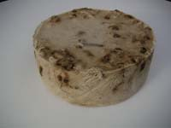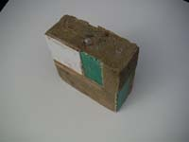

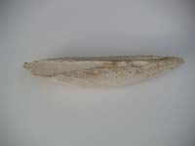

The works look similar to the work of Claes Oldenburg However whilst ‘presence’ may make implicit reference to bakery in the making it is not representational of baking in the same way as Oldenburg’s work.

‘Self Addressed 7’

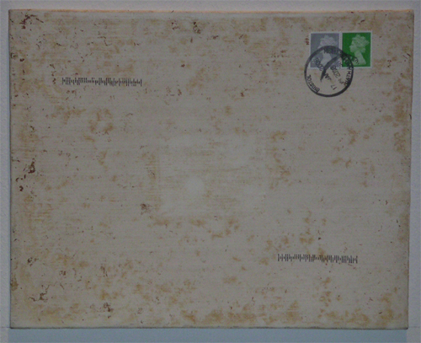

These works embody the process of ‘letting go’. They are heavily prepared with gesso canvas board and contain the first second eight and last pieces to have been sent in the post to my home address during the MA course.

On Kawara,
Uses this method of, sending work to him self in the post as affirmations of life, that he is still present in the world. I use this method to enable marks beyond my control to impact on the work, to become part of their making. I use nature and others in this way in the making of work.

They are presented in pairs a reference to closeness of the time in their production. They are presented as snapshots of time with a distance between them within which the others produced during the MA would have been. The space between represents a time line. The bottom left hand piece formed the print block to a series of mono prints produced during semester two. The surface of this piece is laden with nicotine staining.

‘Separation and relocated self’

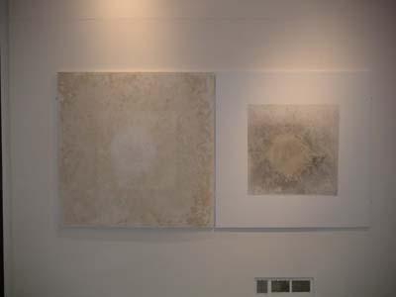

Separate paintings presented here as one were made in a lengthy process over time. Prepared Marine Ply robust enough to withstand weathering process and maintain longevity prepared with Gesso, A square of paper laid on the surface. 7 ounces of tobacco together with six months ash and hand rolled cigarettes was spread on the surface, this was soaked with water. The right hand board was then pressed on top with a paper frame in-between. Left for seven days outside to weather then the right hand board was brought in to dry.

The left hand board was left outside again to weather cleaned then used as a base on which a circle of paper was laid as a protective space. I spread a further two months ashtray contents and 3 more ounces of tobacco on to the surface and proceeded to use my own body and immerse myself in the nicotine rubbing it into the surface of the board. It was then left to weather in the rain for two days.

The right hand board was treated differently. It had the eventual materials used in the left board placed in the centre and nature allowed to work with it. Then a border was applied in white gesso. Both pieces were rigorously cleaned back to their current condition.
These pieces could be considered to refer to the, White paintings of Kazamir Malevich 1915 - 17 and in response Gerhard Richter, Robert Raushenburg, Robert Ryman

These works use different approaches combined the underlying processes and techniques akin to Richter, Raushenburg and Ryman again in response to the supremacist approach of Malevich. Rather than dominate over nature the process works with nature, a process that will continue as they mature with age.

‘Addiction’ Self portrait

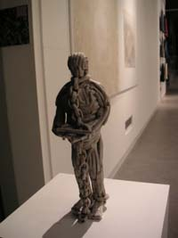

This installation uses 3 separate elements in relationship with each other.

The sculptural figure is made from approximately 300 hand rolled cigarettes. The figure is representational of the body. It is chained up as a prisoner or slave. It is chained with a chain of cigarettes. It refers to the enslavement of the self to addiction and consumerism. The figure looks at a no smoking sign and beyond to the outside.

It is inside yet still tied to itself to nicotine, addicted. Outside the gallery space is a space that smokers use, excluded from the inside. The figure overlooks them. Behind the figure is a photograph of cigarette ends that has been sent in the post to my self. It refers to the past or the looked for past behind the figure. The installation is both a site specific response to the gallery space and the relationship to the use of its outside spaces and a need specific piece in the context of social change and social and cultural issues.

This piece re-integrates my work in the field of community arts and with rest of the work shown, it is the connective strand into re engagement with socially engaged and issues based practice.

Summary conclusion

I realise now in this last semester and on reflection and in the process of writing this evaluation report that some of the underlying questions, long held beliefs, claim to knowledge, and understandings that I have held for many years, to have been misinformed.

There has been an undeniable shift in my thinking during this action research. I have found that the preconceived ideas, misguided assumptions on the nature of creativity and changes in my thinking have forced me to question the foundations of my thinking.

I now question further the philosophical foundations laid down in the background context.
That is not to say that I either agree or disagree with the ideas and concepts, but that further work is still to be done. I no longer hold rigidly to them but continue to question them, challenge and test them.

The one remaining idea is the Zen words of Tich Nhat Hanh and the Dalai Lama. These hold and will prevent me from a Nihilistic, Cynicism.

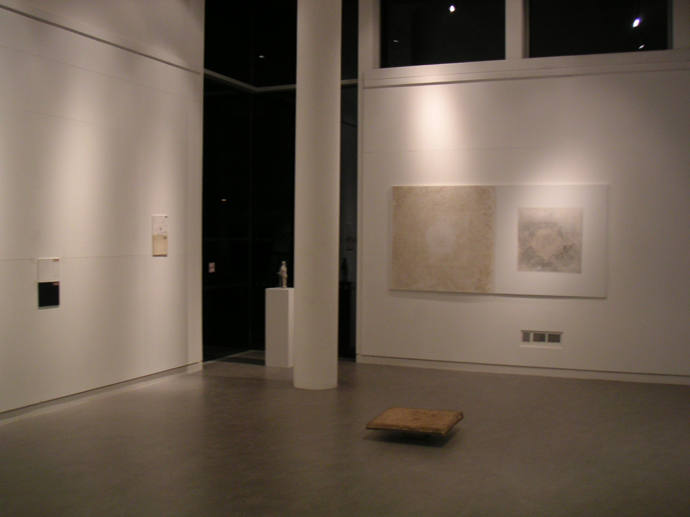

‘Completion’

“Our work today as artists is not about describing the arrival at and possession of a goal, but instead it is about illuminating the pathway. It is not about a system of proofs and declarations, but a process of being and becoming” Bill Viola

“As it has been in the past, art for me is a means to arrive at the point of knowing more, not of creating something that is merely beautiful, interesting to look at, or provides a new step in the discourse of contemporary art and art history”
And what are the underlying principles of what art can do.

“Among other things, art is a system for exploring, defining and expressing values – a kind of tool box that allows people to examine and re-imagine the values that they or others hold”

‘Failure takes people different ways. It can utterly destroy or build a personality’s confidence; it can activate a spiral of depression or be a stimulus’ Edward De Bono 1986. The failures identified in this evaluation will be a stimulus. De Bono elaborates on learning from failure.

‘If you win an argument you end up with a feeling of glory but little else. Success is an affirmation but not a learning process. There are times when failure has a value as a teacher’

‘If we treat the past as an experiment, then we devise a better experiment for the future’

The project has been a project based on action research, a reflective practice based research project,, and this evaluation report has profound implications for me and the future development of this work.

“For two years I had already been thinking I was better than my work” and “I was my work, I was the essence of work, after I am dead my work is not going to be half as good, it is impossible”

When I am dead I hope that my work continues, not so that I can be remembered, not so that my name lives on but because I seek to leave the world a better place than when I arrived

Andrew Henon 27th January 2008

Bibliography

Art meets Science and Spirituality. Art and Design Academy Editions 1990, London, ISBN 1 85490 038 2

Barthes Roland, Mythologies, Translated by Annette Lavers, Vintage, 2000,
ISBN 0 09 997220 4

Benjamin Andrew, Painting as object, Academy editions, 1994, ISBN 1 85490 361 6

Beuys Joseph, Art into society, society into art, London institute of contemporary art, 1974.

Bourgeois Louise, Destruction of the father, reconstruction of the father, Writings and interviews, Cambridge Press 1998

Bragg Melvin, Tracy Emin, Interview, The South Bank Show, ITV, 19-8-01

www.capefarewell.com

Capra Fritjof, The Web of Life, Harper Collins, 1997, ISBN 0 00 654751 6

Crone Rainer, Moos David, Kazamir Malevich, The Climax of Disclosure, Reakton Books, 1991, ISBN 0 948 46221 3

De Bono Edward, Tactics, The art & Science of success, Fontana, 1986 (p 52)
ISBN 0 00 637072 1

Dictionary of Philosophy, Penguin reference, Penquin Books, 2005, ISBN 0 141 01840

Emin Tracy, Strangeland, Hodder and Stoughton, 2005, ISBN 978 0 340 76946 1

Foucault, Textural Strategies: Perspectives in Post Structuralist criticism, Ithaca, 1979

Gabo Naum, Circle – International Survey of constructive Art, London, 1937

Godfrey Tony, Conceptual Art, The crisis of authority, Phaidon, 2003, ISBN 0 7148 33886

Gray, Carole, Visualizing research a guide to the research process in art and design, Ashgate, 2004. ISBN 0754635775

Greenfield Susan, Brain Story, BBC worldwide Ltd, 2000, ISBN 0 563 55108 9

Hanley Lynsey, Estates, Granta, 2007, ISBN 13 978 1 86207 909 0

Henon Andrew, Cascade, Edited by Kiziewicz Morag, Biggs Ian, University of Bath, 2007,
ISBN 0 86197 137 X

Hirst Damien, Home Sweet Home, 1996. Jacket illustration to Kuspit, End of Art. Cambridge university press, 2004

Horizon, We Love Cigarettes, DVD 29th June 2006 BBC 2

Kawara On, Phaidon, 2002, ISBN 07148 4104 8

Kawara On, Consciousness, meditation, watcher on the hills,Frank Gautherot, Les presses du reel and Ikon Gallery, ISBN 2-84066-078-4

Landy Michael, Breakdown, 2001 Artangel, ISBN 1902201108

Lyotard Jean-Francois, Translated by Regis Durand ‘What is post modernism’ I and S Hassan Innovation/Renovation, Madison 1983

www.leeds.ac.uk/educol/documents/166811.htm

Lucas Sarah, Fag Show, 2000, Sadie Coles Gallery, 35 Heddon Street London W1

Lucus Sarah, www.tate.org.uk vnweb.hwwilsonweb.com www.telegraph.co.uk

Lucus Sarah, Museum Boyman, 1996, ISBN 90 6918 163 0

Lyotard, F. The Postmodern Condition, A report to Knowledge. Manchester University Press 1986, ISBN 0 7190 1454 9

Matarasso Francois, Locucum, 20th February 2005 and nesa art|speak seminar October 2007

McNiff Jean, Whitehead Jack, Action Research Principles and Practice, Routledge, 1992,
ISBN 0415 09096 2

http://www.mgestaltc.force9.co.uk/a_gestalt_approach_to_learning.htm

Oldenburg Claes, Tate Gallery, London 24th June – 16th August, 1970

Philips Helen, Creative Minds, Looking for Inspiration, New Scientist, 29th Oct 2005.

Pope Rob, Creativity, Theory, History, Practice, Routledge, 2006,
ISBN 13 978 0 415 34916 1

Richter Gerhard, The daily practice of painting, Thames and Hudson 1995,
ISBN 978 0 500 278369

Rogers Carl, A Way of Being, Houghton Miflin, 1980 ISBN 0 395 30067 3

Sullivan Graeme, Visual Knowing, Art practice as research, Sage Publications,1st
published 1951, reprinted 2005 ISBN 1-4129-0536-2

Tich Nhat Hanh, The Heart Of Understanding, Edited by Peter Levitt, Parallax Press, Berkley, California, 1988, ISBN 0 938077 11 2

Viola Bill, Reasons for Knocking at an empty house, Writings 1973 – 1974, Edited by Robert Violette, 1995,

Whitehead Jack http://people.bath.ac.uk/edsajw/writings/livtheory.html

Whitehead Jack www.jackwhitehead.com/jack/arplanner.htm

Art meets Science and Spirituality. Art and Design Academy Editions 1990, London, ISBN 1 85490 038 2
Breakdown, Landy Michael, 2001 Artangel, ISBN 1902201108
Dictionary of Philosophy, Penguin reference, Penquin Books, 2005, ISBN 0 141 01840
Capra Fritjof, The Web of Life, Harper Collins, 1997, ISBN 0 00 654751 6
The Heart Of Understanding, Tich Nhat Hanh, Edited by Peter Levitt, Parallax Press, Berkley, California, 1988, ISBN 0 938077 11 2
Art meets Science and Spirituality. Art and Design Academy Editions 1990, London, ISBN 1 85490 038 2
Conceptual Art, The crisis of authority, Tony Godfrey, Phaidon, 2003, ISBN 0 7148 33886
Beuys Joseph, Art into society, society into art, London institute of contemporary art, 1974.
http://www.mgestaltc.force9.co.uk/a_gestalt_approach_to_learning.htm
Foucault, Textural Strategies: Perspectives in Post Structuralist criticism, Ithaca, 1979
Emin Tracy, Strangeland, Hodder and Stoughton, 2005, ISBN 978 0 340 76946 1
Benjamin Andrew, Painting as object, Academy editions, 1994, ISBN 1 85490 361 6
Whitehead Jack http://people.bath.ac.uk/edsajw/writings/livtheory.html
Whitehead Jack www.jackwhitehead.com/jack/arplanner.htm
Whitehead Jack www.jackwhitehead.com/jack/arplanner.htm
www.leeds.ac.uk/educol/documents/166811.htm
Lyotard, F. The Postmodern Condition, A report to Knowledge. Manchester University Press 1986, ISBN 0 7190 1454 9
Hanley Lynsey, Estates, Granta, 2007, ISBN 13 978 1 86207 909 0
Barthes Roland, Mythologies, Translated by Annette Lavers, Vintage, 2000, ISBN 0 09 997220 4
Pope Rob, Creativity, Theory, History, Practice, Routledge, 2006, ISBN 13 978 0 415 34916 1
Henon Andrew, Cascade, Edited by Kiziewicz Morag, Biggs Ian, University of Bath, 2007, ISBN 0 86197 137 X
Philips Helen, Creative Minds, Looking for Inspiration, New Scientist, 29th Oct 2005.
Hirst Damien, Home Sweet Home, 1996. Jacket illustration to Kuspit, End of Art. Cambridge university press, 2004
We Love Cigarettes, Horizon, DVD 29th June 2006 BBC 2
Greenfield Susan, Brain Story, BBC worldwide Ltd, 2000, ISBN 0 563 55108 9
www.capefarewell.com
Bourgeois Louise, Destruction of the father, reconstruction of the father, Writings and interviews, Cambridge Press 1998
Lyotard, F. The Postmodern Condition, A report to Knowledge. Manchester University Press 1986, ISBN 0 7190 1454 9
Bourgeois Louise, Destruction of the father, reconstruction of the father, Writings and interviews, Cambridge Press 1998
Art meets Science and Spirituality. Art and Design Academy Editions London, 1990 ISBN 1 85490 038 2
Fag Show, Sarah Lucas, 2000, Sadie Coles Gallery, 35 Heddon Street London W1
Sarah Lucus, www.tate.org.uk vnweb.hwwilsonweb.com www.telegraph.co.uk
Lucus Sarah, Museum Boyman, 1996, ISBN 90 6918 163 0
Richter Gerhard, The daily practice of painting, Thames and Hudson 1995, ISBN 978 0 500 278369
Gabo Naum, Circle – International Survey of constructive Art, London, 1937
Lyotard Jean-Francois, Translated by Regis Durand ‘What is post modernism’ I and S Hassan Innovation/Renovation, Madison 1983
Oldenburg Claes, Tate Gallery, London 24th June – 16th August, 1970
On Kawara, Phaidon, 2002, ISBN 07148 4104 8
On Kawara, Consciousness, meditation, watcher on the hills,Frank Gautherot, Les presses du reel and Ikon Gallery, ISBN 2-84066-078-4
Crone Rainer, Moos David, Kazamir Malevich, The Climax of Disclosure, Reakton Books, 1991, ISBN 0 948 46221 3
Godfrey Tony, Conceptual Art, The crisis of authority, Phaidon, 2003, ISBN 0 7148 33886
Benjamin Andrew Object • Painting, Academy Editions, 1994, ISBN 1 85490 361 6, Painting as object : Robert Ryman
Reasons for Knocking at an empty house, Writings 1973 – 1974, Bill Viola, Edited by Robert Violette, 1995, ISBN 0-500-27837-7
Reasons for Knocking at an empty house, Writings 1973 – 1974, Bill Viola, Edited by Robert Violette, 1995, ISBN 0-500-27837-7
Matarasso Francois, Locucum, 20th February 2005 and nesa art|speak seminar October 2007
De Bono Edward, Tactics, The art & Science of success, Fontana, 1986 (p 51) ISBN 0 00 637072 1
De Bono Edward, Tactics, The art & Science of success, Fontana, 1986 (p 52) ISBN 0 00 637072 1
De Bono Edward, Tactics, The art & Science of success, Fontana, 1986 (p 52) ISBN 0 00 637072 1
McNiff Jean, Whitehead Jack, Action Research Principles and Practice, Routledge, 1992, ISBN 0415 09096 2
Sullivan Graeme, Visual Knowing, Art practice as research, Sage Publications,1st published 1951, reprinted 2005 ISBN 1-4129-0536-2
Gray, Carole, Visualizing research a guide to the research process in art and design, Ashgate, 2004. ISBN 0754635775
Bragg Melvin, Tracy Emin, Interview, The South Bank Show, ITV, 19-8-01

